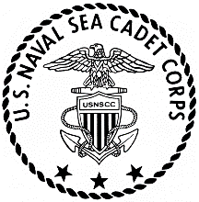**COMMANDING OFFICER**

**FIRELANDS DIVISION**

**U.S. NAVAL SEA CADET CORPS**

[www.firelandsseacadets.org](http://www.firelandsseacadets.org)

[marcumnscc@gmail.com](mailto:marcumnscc@gmail.com)

7323 Market Ave N

Canton, Ohio 44721

26 JUN 23

From: Commanding Officer, Firelands Division

To: All Hands

Subj: **2023-2034 TY DRILL DATES**

1. These are the drill dates for the next training year:

12/13 AUG

16/17 SEP

07/08 OCT

11/12 NOV

02/03 DEC

20/21 JAN

17/18 FEB

09/10 MAR

13/14 APR

11/12 MAY

15/16 JUN

06/07 JUL

10/11 AUG

14/15 SEP

1. These are mandatory drill dates. Mark your calendars so you can make necessary arrangements for attendance.

D. N. Marcum

LCDR, NSCC